ITEC 4550 Exam 1 – Coding Problem

Description
You will build an app that implements the following high-level concept:
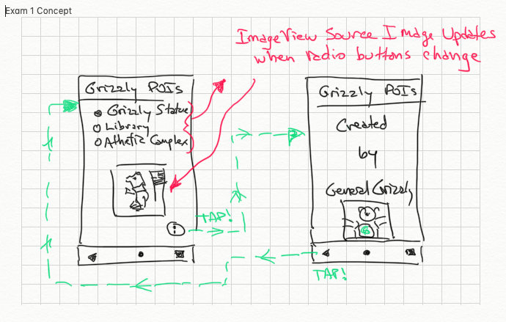
For the initial screen, the layout spacing should resemble the prototype above. The implementation is up to you. For the second “About” activity, the layout should conform to this spec:

A video of complete, working app can be viewed HERE.
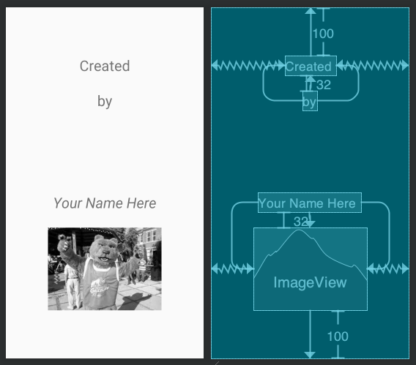

Requirements/Rubric
Requirements /Rubric:
Points | Item
5 | Application title correct
10 | RadioButtons present, values correct, selection changes image properly
10 | RadioButton text size is 30sp
10 | Floating Action Button (FAB) launches “About” activity correctly
5 | FAB icon set to lowercase i
10 | “About” activity present with text and image, conforms to blueprint spec provided above
10 | POI image present in MainActivity (statue, library, athletic complex)
5 | Add verbose log statement(s). Your app writes a verbose-level Log message to the logcat every time the image in the MainActivity changes. The log message contains the tag “GrizzlyPOI”. For example:  2019-09-17 16:16:11.360 8546-8546/edu.ggc.lutz.grizzlypoi V/GrizzlyPOI: statue selected  Your entry does not need to have the same package name as shown.
10 | Launcher icon changed to ‘Drop Pin” or other graphic of your choosing

Hints / Notes
Example video and screens are provided for reference; however, you can design the app as you see fit, as long as you conform to the specifications listed above.
Your app does not need to provide responsive behavior for device configuration changes. Testing the emulator (or device) in portrait is adequate.
Use incremental programming. Some features are easier than others. You may want to snapshot your entire project when you reach a new milestone, this way it’s easy to move backwards if you encounter a feature that you can’t complete. A good way to create a snapshot of the project is by copying the project folder or zipping it.
Default colors are ok – no need to change

Submission

Clean your project, compress it as a zip archive and submit the zip the appropriate folder in the Assignments dropbox in D2L.
A demonstration video recording of your app is not required.

Resources

Image resources can be found in the D2L Assignments folder.

